UCCE-Fresno County letterhead
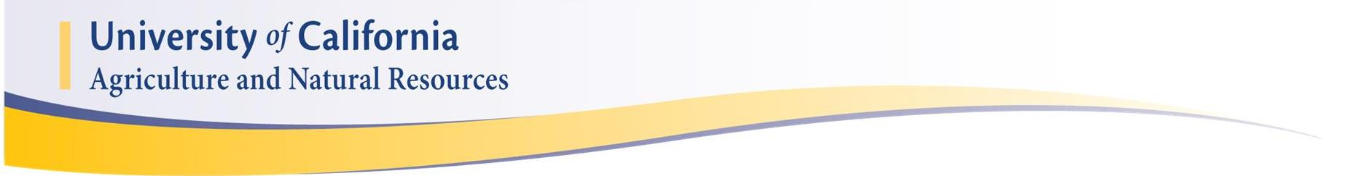

Surface Irrigation Efficiency Workshop

This workshop is designed to give growers and water managers tools and insights on how to better conduct surface irrigation activities including furrow, border and basin (flood) irrigation systems. Topics include basic system design issues, performance evaluation approaches and commonly used practices to improve the distribution uniformity and efficiency of applied water.

Friday June 3, 2016

Location: UC Kearney Agricultural Center
9240 S. Riverbend Ave
Parlier, CA 93648
Nectarine Room

Date: June 3, 2016
Time: 9:00 AM- 12:00 AM

Registration Fee: Free

Agenda
8:30 AM- 9:00 AM Registration and Refreshments
9:00 AM-9:10 AM Introductory remarks and welcome- Nicholas Clark, UCCE- Kings/Tulare County
9:10 AM -9:30 AM Practical Application for Improving Surface Irrigation Efficiencies, Dan Munk,
UCCE-Fresno County
9:30 AM-9:50 AM Irrigation Systems and Energy Efficiency, Daniele Zaccaria, UC Davis
9:50 AM- 10:10 AM Improving the Efficiency of Surface Irrigation Systems, Eduardo Bautista, ARS-USDA
10:10 AM-10:30 AM Break
10:30 AM-11:10 AM The relationship between irrigation efficiency and field geometry, field condition, and inflow rate into the irrigated field, Eduardo Bautista, ARS-USDA
11:10 AM-11:30 AM Understanding Irrigation Efficiency with Different Systems: How it’s Defined, Why it’s Important- Khaled Bali, UCCE-Imperial
11:30 AM- 12:00 PM Q&A
To register for the workshop or for additional information, please email or call Dan Munk or Terri Gonzalez (email:dsmunk@ucanr.edu, 559-241-7515). Event registration is optional but preferred to estimate attendance.

Our programs are open to all potential participants. Please contact the Fresno UCCE office (two weeks prior to the event) at 559-241-7515 if you have any barriers to participation requiring special accommodations.
It is the policy of the University of California (UC) and the UC Division of Agriculture & Natural Resources not to engage in discrimination against or harassment of any person in any of its programs or activities (Complete nondiscrimination policy statement can be found at http://ucanr.edu/sites/anrstaff/files/215244.pdf )
Inquiries regarding ANR’s nondiscrimination policies may be directed to John I. Sims, Affirmative Action Compliance Officer/Title IX Officer, University of California, Agriculture and Natural Resources, 2801 Second Street, Davis, CA 95618, (530) 750-1397.

